William Conley

Infection Spread Simulation

CSCI 3010U

**Introduction**

Our project simulates the COVID-19 infection spread model that attempts to show how the virus spreads through a population. In this simulation, people are represented as particles that move around randomly, and are coloured according to their state. At the initial state of the simulation, we specify the number of people in each state to generate and allow them to move through the simulation until it reaches a resting state: when everyone in the simulation is either healthy, cured, or dead.

**Related Work**

This project was inspired by a <<insert year of paper>> paper by <<insert authors>> which discussed their model of the COVID-19 epidemic. Using data collected in Italy during the virus’ initial contact, the authors created a series of differential equations that described how the virus spread through the population. They then used their model to make population projections across the different states over time. In their model, the authors used an entirely mathematic approach with representation of the different states as a series of plots that displayed the change over time of the various states.

This work <<what work? Yours or the authors?>> ran several demonstrations of the spread of the virus using different scenarios. In the initial test, the disease was allowed to spread through the population unimpeded. In the additional tests, different scenarios were enacted by changing the values of the equations’ variables (e.g., reducing an infectivity variable to represent implementing social distancing). In the work, the effectiveness of such measures was shown by comparing the large difference in the number of people who had been infected over the course of the simulation, and who had died.

This work uses the following states:

* **Susceptible** – The individual is not infected.
* **Infected** – The individual is infected, but not detected.
* **Diseased** – The individual is infected and detected.
* **Ailing** – The individual is infected and symptomatic, but not detected.
* **Recognized** – The individual is infected, symptomatic, and detected.
* **Threatened** – The individual is infected, severely symptomatic and detected. Their symptoms are so severe that it is obvious they are infected.
* **Healed** – The individual has been cured from their disease and has temporary immunity.
* **Extinct** – The individual has died and no longer participates in the simulation.

Figure 1 below shows the variables associated with each change in state.

*Figure 1: Flowchart of state changes (Giordano et al., 2020)*

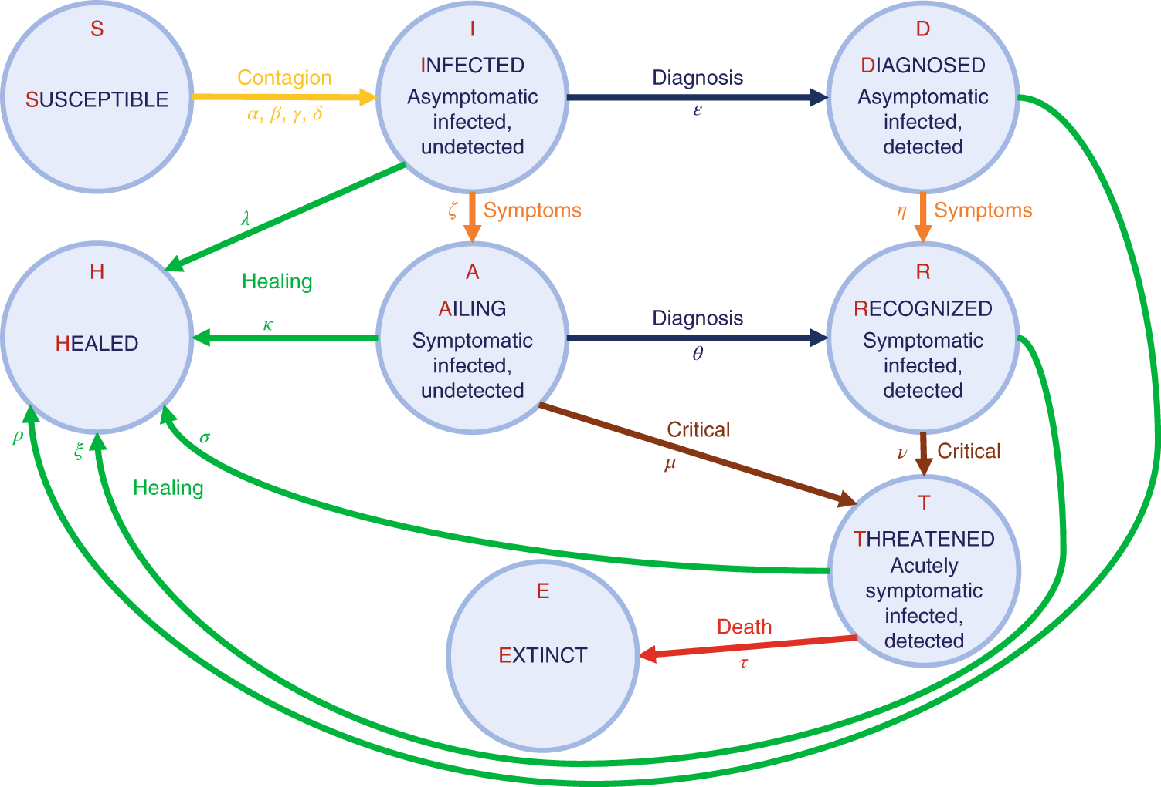

* α – Transmission rate from an infected subject.
* β – Transmission rate from a diagnosed subject.
* γ – Transmission rate from an ailing subject.
* δ – Transmission rate from a recognized subject.
* ε – Detection rate for an infected subject.
* θ – Detection rate for an ailing subject.
* ζ – Progression rate for an infected subject.
* η – Progression rate for a diagnosed subject.
* μ – Progression rate for an ailing subject.
* ν – Progression rate for a recognized subject.
* τ – Mortality rate for a threatened subject.
* λ – Recovery rate for an infected subject.
* κ – Recovery rate for a diagnosed subject.
* ξ – Recovery rate for an ailing subject.
* ρ – Recovery rate for a recognized subject.
* σ – Recovery rate for a threatened subject.

**Methodology**

In our project, the simulation is conducted using two objects: a simulation object which controls the simulation and stores global statistics, and people objects which move throughout the simulation. The simulation object is set up with an array of people and updates them as the time step progresses. The simulation is set to create 50 susceptible people and 2 infected people in random places in the simulation’s bounds, but the simulation can be changed to create any number of people with any state.

People in the simulation are given a random angle of movement with a global set speed for each person. At each time step the people change their angle randomly by a few degrees and reflect off the walls of the simulation if they collide with it. This approach builds on the mathematical model by creating a particle simulation of people.

The values of the variables used in the paper’s differential equations for the different rates have been repurposed in our simulation to represent probabilities of changing state when in contact with other people. Each stage of infection has been given a “radius of infection”; when uninfected individuals are within this radius, they are given the appropriate percent chance (weighted by time elapsed) to become infected themselves. Additionally, each person has been given a “radius of vision”; when infected individuals are within the radius, they are given the appropriate percent chance to become detected, as if the individual that saw them told them “based on your appearance, I think you’re infected”. For state changes such as progression in symptoms (asymptomatic to symptomatic, symptomatic to acutely symptomatic), the mortality rate (alive to extinct), and recovery rate (infected to healthy), the people were given a permanent random chance to change states, independent of the other people.

Additionally, several modifications were made to the state change parameters to accommodate the simulation being transformed from a mathematical model to a particle simulation. Rather than use different probabilities for infection by detected vs. undetected states, the people’s moving was modified instead. Detected and undetected states use the same probabilities for infecting others, but people in the simulation will change their path direction to avoid infected individuals. Specifically, when infected individuals are within the field of view of another person, their angle of direction will move away from the location of the infected person to avoid them, indirectly reducing the opportunity for people to be infected Another modification was to divide all probabilities by a factor of 10, to account for the radius of infection each infected person projects, because with the natural probabilities (even accounting for time), stages were progressing too rapidly.

These simulations continue to run until every person in the simulation becomes susceptible, healed, or extinct. Once the simulation concludes, a stacked line plot was created to demonstrate the changes in state over time, which can then be compared to the results of the mathematical model.

**Results**

As the simulations ran, a few unintended consequences of the pathing logic were observed. For example, as more “people” changed to infected/detected states, there became so many infected “people” that there was very little movement before “seeing” a new “person” to avoid. As a result, they would begin to spin in place, in small circles. This gave the impression of social distancing, with people staying roughly equally spaced apart. Another example of an unintended consequence was that although people would avoid infected/detected people, the infected/detected people do not avoid healthy people to avoid infecting them. Consequently, over time when there are many infected/detected people, those infected people seemed to herd the few remaining healthy people together, which would cause a surge in infection once one of these people is infected/undetected. Upon reflection, it seemed like it was unexpectedly emulating a super-spreader event.

The simulation was run 4 times to explore how variable the random probability of the state changes were. As can be seen in figure 2, a series of stacked area plots were created to visually present the variation across the states for each simulation. Although the undetected/detected states are not distinguished, healed individuals are represented as green, susceptible individuals are represented as blue, extinct are represented as black, and different stages of infections are represented by different shades of red with light red representing lower symptomatic levels and darker red representing higher symptomatic levels.

*Figure 2: Stacked Area Plot Series of Simulation State Changes*

**Discussion and Conclusions**

Generally, the death rate tended to slow down at an exponential rate, while the population of infected individuals fluctuated. This is seeming to emulate the balance between an initial outbreak in unsuspecting people and subsequent decline of infectious spread as people become aware of symptoms and avoid infected people. With a decline in infection, the cycle begins again with a few undetected/infected individuals again moving through the healthy population and quickly spreading the disease again. This cycle continues until the total population has the space to spread out enough to avoid contact and let the infection burn out.

To compare the infection subpopulations and their change over time, the results of Giordano et al. (2020) mathematical are presented in Figure 3 and the results of the simulation are presented in Figure 4. As can be seen in Figure 4, the overall shape of the plot resembles the overall shape of the author’s model as presented in Figure 3 d. Upon closer inspection, there is a difference in terms of the actual classes. It appears that the “diseased” stage has exchanged places with “recognized”, and “ailing” with “threatened” in the plot.

Figure 3: (Giordano et al., 2020) Plots of Mathematical Model Results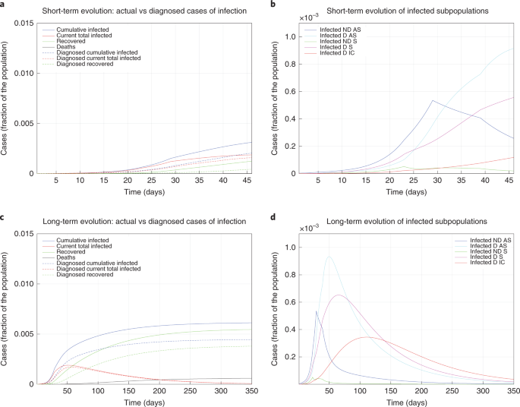

Figure 4: Line Plot of the Simulation Model Results

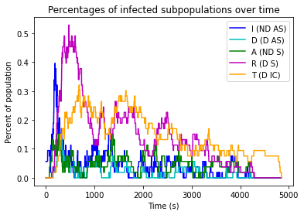

This is variation is most likely due to the disease progressing in people faster than the mathematical model would expect. In the simulation infected people have a permanent chance each tick to progress in infection, but healthy people only have a chance each tick to become infected when they are in the radius of an infected person. Variations from the mathematical model are not unexpected and were anticipated as implementation decisions were made building the simulation. However, the incredible similarity of the plots leads us to conclude that despite its limitations, this particle simulation still stays true to the numerical model.

**Limitations**

This simulation suffers from several limitations because of how the mathematical model was adapted. As has been mentioned, the simulation progresses too quickly for infected individuals when compared to the author’s model. Another limitation is the smaller number of events that are accounted for in the simulation than in the author’s model. For example, the author’s original modelled the spread of infection in Italy, describing hospitalizations where patients are presumably receiving care. The simulation, on the other hand, had a single “healed” class where the associated probabilities were built on the assumption of a person’s immune system randomly beating the infection. The presence of a hospital to seek treatment is not accounted for, neither are behavioural and geographic consideration such as isolated communities, public perception of the infection’s severity, popular events that draw in people from across the country, etc. While the people in our simulation move randomly and avoid the infected people they are aware of, there are greater complexities that could be modeled.

**Future Work**

Considering further development of this simulation, additional logic could be applied to the pathing of people. For example, physical locations such as “stores” that people would gather at would provide a more realistic motion than random movement. Personalities could be developed that could influence behaviour. For example, a “paranoid” personality could include avoidance behaviour regardless of anyone’s infection state. An “uncaring” personality could include a seeking behaviour that does not include any avoidance. An “altruistic” personality could avoid uninfected individuals once infected themselves.

The variables in the simulation could also be adjusted to reflect the plot of the author’s model more accurately. In the simulation, infection by “threatened” individuals was negligible, but it could be designed to account for it. The progression of infection needs to be reworked somehow, as both the percentages for infection and progression were taken from the mathematical model, but while the infection calculations only occur while in the range of infected individuals, the progression calculations occur all the time. Like the inclusion of “stores”, it would be interesting to include a “hospital” resource that could account for treatment of a limited number of people at a time. Finally, more recent research demonstrating the continued infectiousness of vaccinated people could be included as an additional interaction.

**References**

Giordano, G., Blanchini, F., Bruno, R., Colaneri, P., Di Filippo, A., Di Matteo, A., & Colaneri, M. (2020). Modelling the COVID-19 epidemic and implementation of population-wide interventions in Italy. *Nature Medicine*, *26*(6), 855–860. <https://doi.org/10.1038/s41591-020-0883-7>